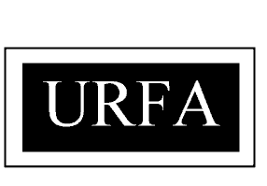

UNIVERSITY OF REGINA FACULTY ASSOCIATION

2022 Nomination Form

To be returned to the University of Regina Faculty Association, by email at urfa@uregina.ca , by no later than 4:30 p.m. Tuesday, February 1, 2022

We, the undersigned, nominate

for election to the Council of Representatives from the Constituency

NAME  (Please Print) | SIGNATURE | DEPARTMENT
1.
2.

I accept the nomination and agree to let my name stand for election.

Signature of Candidate

Return To: R. MacLennan
Returning Officer
URFA Office
Email: urfa@uregina.ca

